Exercise 1



Exercise 2

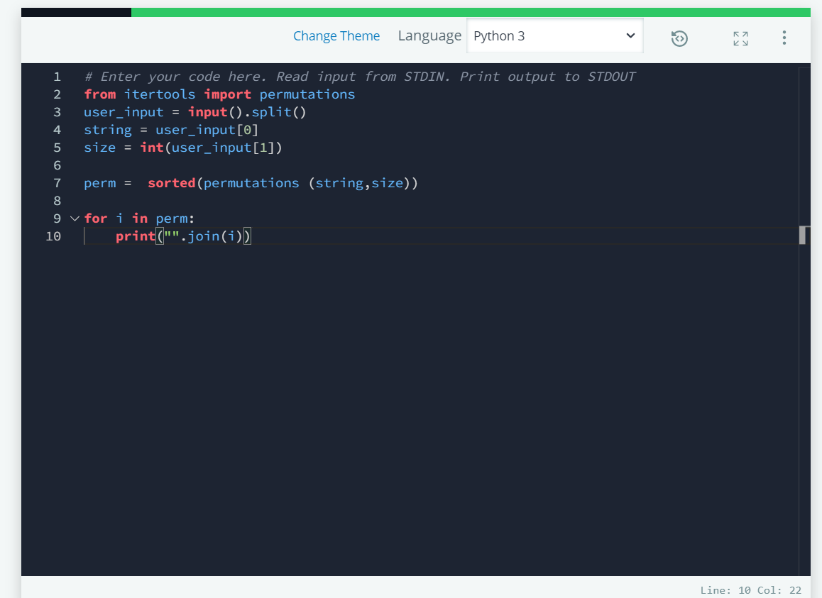



Exercise 3

